Volume Project
Designing a Wedding Cake
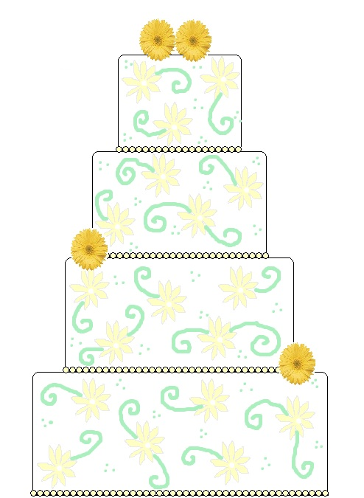
September 2015

Name: __________________________
Mr. Meyer’s brother’s uncle’s sister is getting married this September and she needs your help designing her wedding cake! Before you begin, use the below box to brainstorm the different tasks that might be involved in designing a wedding cake for a large group of people. (Bride and Groom’s interests – Halloween, Spartan Races, Reading, Animals, Beach, and Trees)

Here are the criteria for the cake:
- The cake must serve between 200 and 250 people.
  - When cut, one slice (one serving) is 10 inches³.
- The cake must have at least three layers.
- Each layer must be a rectangular prism.
- At least one layer must be vanilla.
- At least one layer must be red velvet.

Flavors:
- A cubic inch of vanilla is $.25
- A cubic inch of chocolate is $.25
- A cubic inch of red velvet is $.50
- A cubic inch of carrot is $.50
Budget:
- You cannot spend more than $650 dollars
*All other costs, including the cost of icing, decorations and tax, are included when you select your flavors.

You must perform the following tasks:
- Design a wedding cake that meets all the criteria
- Decide how many layers your cake will have and the volume and flavor of each layer
- Show the cost of each layer with considerations to size and flavor
- Sketch a cake design
- Persuade Mr. Meyer to choose your cake design

Part 1: Understanding the problem
- Write, in your own words, what you are expected to do to design this cake?
__________________________________________________________________________________________________________________________________________________________________________________________________________________________________________________________________________________________________________________________________________.

- What information is given to you to help you design the cake?
__________________________________________________________________________________________________________________________________________________________________________________________________________________________________________________________________________________________________________________________________________.

Part 2: Planning
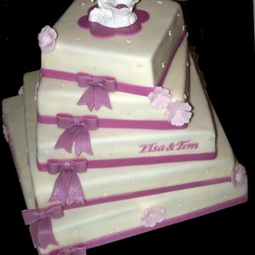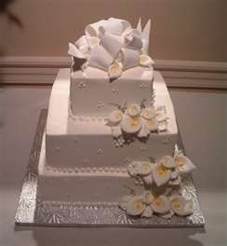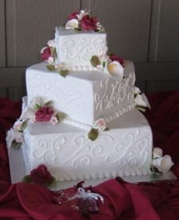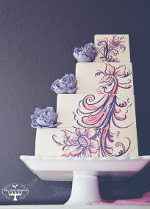
*These are some examples of wedding cakes that could meet the criteria for the cake. Use these pictures to begin thinking about what you’d like your cake to look like.
- What are the steps you will need to follow to design the wedding cake?
- Decide how many layers my cake will have

2) Use words, pictures, or symbols to help you make a plan for designing the cake. On the next page you will sketch a rough draft of your cake design.

Part 3: Initial Draft of the Wedding Cake
- Use this page to create a rough sketch of the cake design. Label each layer with its length, width, and height. Also, label each layer’s flavor. A table for your calculations for each layer’s volume and cost is on the next page.

Part 4: Work and Calculations
Complete the table below and use the rest of this page for calculations. Show your work! If you only have three layers to your cake, you will only use the first three rows.
Layer | Flavor | Cost per cubic inch | Length  in inches | Width in inches | Height in inches | Volume in cubic inches | Amount of people layer feeds  (Volume / 10) | Total cost of layer (cost per cubic in x volume)
1-top
2
3
TOTAL

Part 5: Explanations
- Explain how you found a way to have enough cake to feed between 200 and 250 people. What is the total volume of the cake?
________________________________________________________________________________________________________________________________________________________________________________________________________________________________________________________________________.
- How many people does your cake feed? (10 cubic inches = one person)
______________________________________________________________________________________________________________________________________________________________________________________________________.

- What is the cost of the entire cake? How close were you to reaching the budget?
______________________________________________________________________________________________________________________________________________________________________________________________________.

Part 6: Final Sketch

Construct a final sketch of your wedding cake design on the provided construction paper. Your final sketch should include labels of all of the dimensions of each layer as well as the total volume. You should also label the flavors of each layer and show the costs of each layer. Be creative and decorate your cake!

Part 7: Persuasive Letter
Now that you and all of your classmates have designed a wedding cake, he needs to choose one design to use. Write a letter to Mr. Meyer about why he should choose your cake for his family’s wedding.
Include the following descriptions:
Describe your cake and discuss each layer. What are the dimensions and the volume of each layer? What flavor is each layer? What is the total volume of the cake? How many people does it serve? How much money does the cake cost to make? How is your cake decorated?
*Your letter will be written on a separate piece of loose leaf paper.

Part 8: Reflections
- You have just encountered a problem where you had to make a wedding cake to feed many people. This required many math skills. Can you think of other situations where you or someone else may need to use these same types of skills?
________________________________________________________________________________________________________________________________________________________________________________________________________________________________________________________________________.

- Explain what you found difficult to do in this problem.
________________________________________________________________________________________________________________________________________________________________________________________________________________________________________________________________________.

- If you had to do this situational problem again, explain what you would do differently.
________________________________________________________________________________________________________________________________________________________________________________________________________________________________________________________________________.

