Unit 5 Review

On the assessment you will need to be able to do the following.
- Find a common denominator for a pair of fractions, and then use that denominator to write the equivalent fractions.
Be able to describe how you found the common denominator __________________________________________________________________________________________________________________________________________________________________________________________________________________________________________

- Use equivalent fractions to help you solve addition/subtraction problems with fractions.
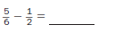

- Estimate an answer and then solve the problem for the exact answer.
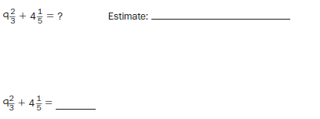

- Solve a word problem. Include a number model, estimate and exact answer.
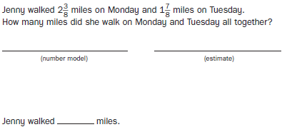
- Solve a fraction-of problem.
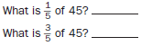

- Solve multiplication problems with fractions.
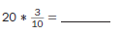
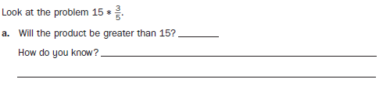
- Write a number story when given two numbers.
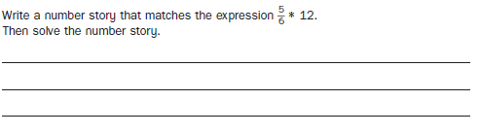
- You will have a shaded rectangle and will have to find the fraction dimensions. Write a number model and then solve.

- Write a division number model with a letter for the unknown, and solve. Then check with a multiplication sentence.
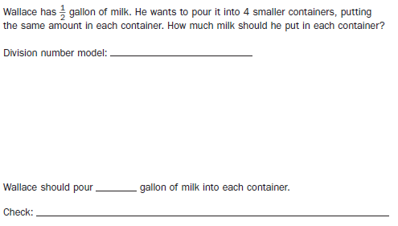

Open response practice:
Jem’s Restaurant is famous for its delicious drinks. Jem’s most famous recipe calls for 1/3 of a bananna, ¼ of an apple and 2/3 of lemon to make one drink. A family of 5 arrives.

- How much of each fruit does Jem need to make the drinks for the entire family? Show your thinking and be sure to use units in your answer.

- Jem has enough lemons for the entire family, however a cook tells him that there is only 1 banana and 1 apple in the kitchen. How many drinks can Jem make. Show your thinking and use units in your answer.

