Name:
Unit 1 Open Response Practice
Jonathan is trying to pack a box of calculators. Each set of calculators is packaged in a box that measures 1 cubic foot in volume.
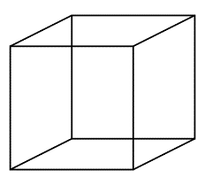
Jonathan is placing the boxes calculators into a larger box to send to a neighboring school district.
- What is the minimum volume of a box that Monica could use to send 40 boxes of calculators? How do you know?

- Jonathan grabs a box with the following dimensions. 2 feet wide, 5 feet long and 3 feet high. Will all 40 boxes of calculators fit in this larger box? How do you Know?
