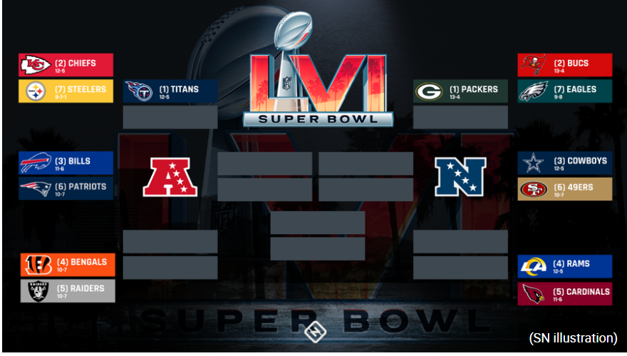
Yards gained | % of Yards (category / total yards = decimal x 100)
Passing Yards = | Passing / Total yards =
Running Yards = | Running / total yards=
Penalty Yards = | Penalty / total yards =
Total Yards = | 3rd Down conversation =

Yards gained | % of Yards (category / total yards = decimal x 100)
Passing Yards = | Passing / Total yards =
Running Yards = | Running / total yards=
Penalty Yards = | Penalty / total yards =
Total Yards = | 3rd Down conversation =

Yards gained | % of Yards (category / total yards = decimal x 100)
Passing Yards = | Passing / Total yards =
Running Yards = | Running / total yards=
Penalty Yards = | Penalty / total yards =
Total Yards = | 3rd Down conversation =

Yards gained | % of Yards (category / total yards = decimal x 100)
Passing Yards = | Passing / Total yards =
Running Yards = | Running / total yards=
Penalty Yards = | Penalty / total yards =
Total Yards = | 3rd Down conversation =

Yards gained | % of Yards (category / total yards = decimal x 100)
Passing Yards = | Passing / Total yards =
Running Yards = | Running / total yards=
Penalty Yards = | Penalty / total yards =
Total Yards = | 3rd Down conversation =

Yards gained | % of Yards (category / total yards = decimal x 100)
Passing Yards = | Passing / Total yards =
Running Yards = | Running / total yards=
Penalty Yards = | Penalty / total yards =
Total Yards = | 3rd Down conversation =

Yards gained | % of Yards (category / total yards = decimal x 100)
Passing Yards = | Passing / Total yards =
Running Yards = | Running / total yards=
Penalty Yards = | Penalty / total yards =
Total Yards = | 3rd Down conversation =

Yards gained | % of Yards (category / total yards = decimal x 100)
Passing Yards = | Passing / Total yards =
Running Yards = | Running / total yards=
Penalty Yards = | Penalty / total yards =
Total Yards = | 3rd Down conversation =

Yards gained | % of Yards (category / total yards = decimal x 100)
Passing Yards = | Passing / Total yards =
Running Yards = | Running / total yards=
Penalty Yards = | Penalty / total yards =
Total Yards = | 3rd Down conversation =

Yards gained | % of Yards (category / total yards = decimal x 100)
Passing Yards = | Passing / Total yards =
Running Yards = | Running / total yards=
Penalty Yards = | Penalty / total yards =
Total Yards = | 3rd Down conversation =

Yards gained | % of Yards (category / total yards = decimal x 100)
Passing Yards = | Passing / Total yards =
Running Yards = | Running / total yards=
Penalty Yards = | Penalty / total yards =
Total Yards = | 3rd Down conversation =

Yards gained | % of Yards (category / total yards = decimal x 100)
Passing Yards = | Passing / Total yards =
Running Yards = | Running / total yards=
Penalty Yards = | Penalty / total yards =
Total Yards = | 3rd Down conversation =

