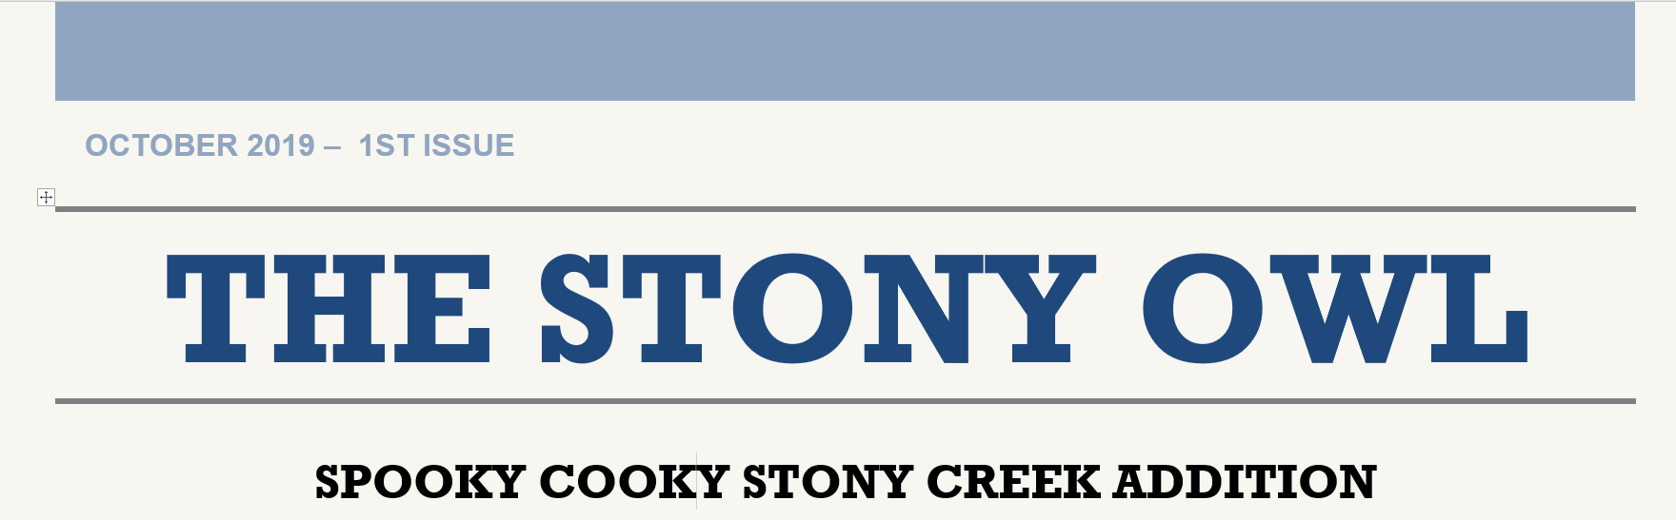
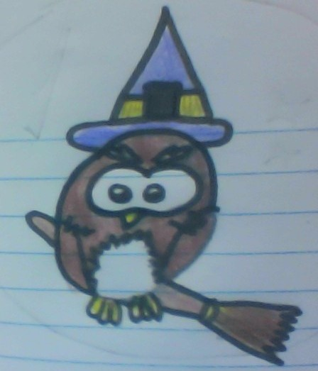  The Stony Owl  Halloween Riddles  - Where do the spirits and souls drop off their letters and packages?  - On what day do you carve a  Jack-O-lantern?  - What do mummies, zombies, vampires, goblins and witches have in common?  - One day a year I am decorated in style. I’m the center of attention when you make me into a pie. What am I?  (see answers below)  Quotes of the month  *Double, double toil and trouble, fire burn and cauldron bubble.  - William Shakespeare  *The beautiful thing about learning is that now one can take it away from you.  -BB King  *Education is the passport to the future, for tomorrow belongs to those who prepare for it today.  -Malcom X  Riddle Answers:  - The Ghost Office  - Hollow-ween  - The letter I  - A pumpkin | 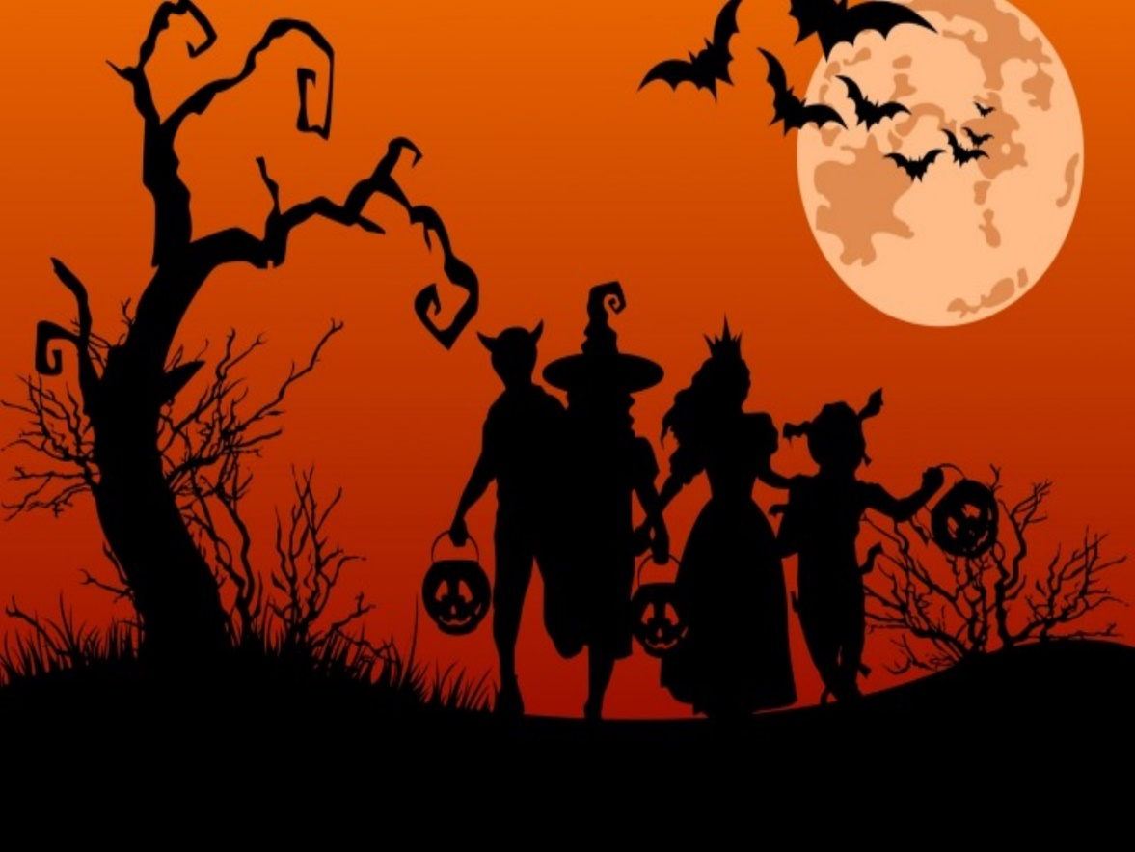  The History of Halloween  Halloween originated from the ancient Celtic festival of Samhain. The Celts lived in  Ireland. Their celebration of the New Year was on November 1st. It was the end of  Summer, the end of crop season, and winter was coming. People thought winter meant death. When Fall came around, people started to talk about death. They thought the boundary between the living and the dead became blurred. On October 31st, they thought the dead came back from the earth. They put food and wine outside for the spirits. They would also wear masks so they would blend in with the ghosts. A man later turned Samhain into All Saints Day, then to All Hallows Day. The night before was called All Hallows Eve.  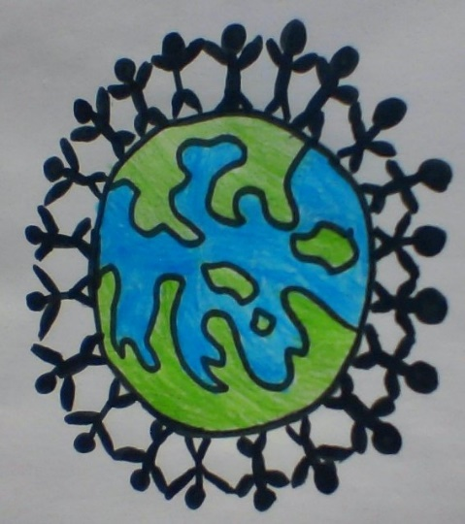  Tips to help the planet!  - Stop brown-bagging lunch.  Pack in a reusable container and use a reusable water bottle.  - Properly dispose of old electronics. When they are exposed to high heat, they release toxic chemicals into the air, water, and ground.

This issue was Created by: Chloe DolL, ELLE COUGHLIN, ALEXA BOWERS, AND SHELLEY-ANN BURKE

