NAME ___________________________________

Grade 5 Unit 7 Self Assessment

Date_____________

  Tyrone is classifying a figure on the quadrilateral hierarchy. He thought, “It has four sides so it must be a quadrilateral. It has one pair of parallel sides so it a trapezoid. It has two ninety degree angles.”

What shape does Tyrone have? ___________________________

Solve.



1. 3 ¼ * 5 3/5 = _____________
2. 5 5/6 * 2 = _____________
3. Explain the strategy you used to solve problem b. ______________________________________________________________________________________

   Find the area of the rectangle.

1 1/3 in.

2 ¼ in.

Answer:___________________

(unit)

     Complete the chart following the rules.

In (x) out (y)

Rule: +2 Rule: +1

0 0

Write a rule to describe the relationship between the in and out numbers.

Rule:____________

http://1.bp.blogspot.com/-YCz1FTEvH78/Unm7PzMOAVI/AAAAAAAAPWs/8RyM6X4q514/s1600/7.png

Graph number 6.

[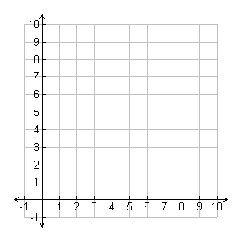](http://www.google.com/url?sa=i&rct=j&q=&esrc=s&source=images&cd=&cad=rja&uact=8&ved=0CAcQjRw&url=http%3A%2F%2Fpixgood.com%2Fcoordinate-grid-quadrant-1-20.html&ei=FxODVZHXKsKYNrK2gOgM&bvm=bv.96042044,d.cGU&psig=AFQjCNHeKs-WVpAKfX3o6t-3hc3hC_gEjw&ust=1434739837016153)

 List as many names for the figure as you can.

_____________________________________________________________________________________________________________________________

Solve.



1. 5 2/5 = _______________

Check: ________________

1. 1/4 [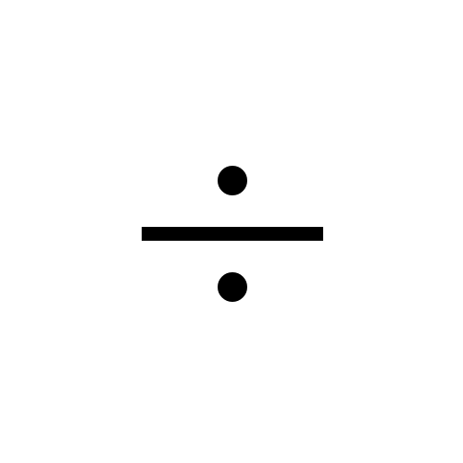](http://www.google.com/url?sa=i&rct=j&q=&esrc=s&source=images&cd=&cad=rja&uact=8&ved=0CAcQjRw&url=http://graphemica.com/%C3%B7/glyphs/times-new-roman-regular&ei=wQyDVffGJIyWgwT75pX4Cg&bvm=bv.96042044,d.cGU&psig=AFQjCNFIBzKfbg_FzuSfnyffZSrkpXbqgg&ust=1434738236605460) 7 = _______________

Check: ________________

[](http://www.google.com/url?sa=i&rct=j&q=&esrc=s&source=images&cd=&cad=rja&uact=8&ved=0CAcQjRw&url=http://graphemica.com/%C3%B7/glyphs/times-new-roman-regular&ei=wQyDVffGJIyWgwT75pX4Cg&bvm=bv.96042044,d.cGU&psig=AFQjCNFIBzKfbg_FzuSfnyffZSrkpXbqgg&ust=1434738236605460)