NAME ___________________________________

Grade 5 Unit 6 Self - Assessment

Multiply.

1. 11.4 * 101 = ________________
2. 11.4 * 102 = ________________
3. 11.4 * 104 = ________________

Divide.

1. 8.4 / 101 = ________________
2. 8.4 / 102 = ________________
3. 8.4 / 104 = ________________



Date_____________

* Complete the “What’s My Rule?”

table. Write the rule as a power of 10 in exponential notation.

RULE: ____________

|  |  |
| --- | --- |
| In | Out |
| 450 | 45 |
| 92 | 9.2 |
| 55 |  |
| 1 |  |
|  | .75 |
|  | 8.9 |



**Plot the following numbers.**

**¼, 1 ½, 1 ¼, 1, .75, 1 ½, 1.75, 1.25**



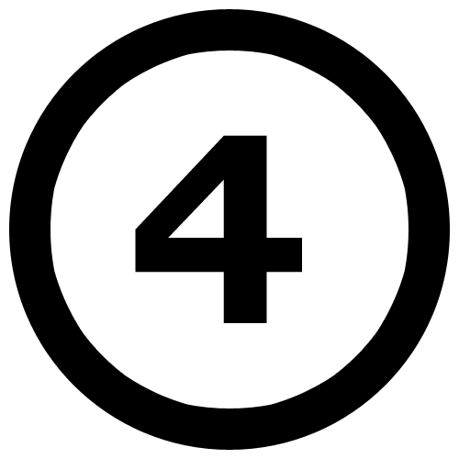 Find the following landmarks.

Max: ______ Mode: ______

Min: ______ Median: _____

Range: _____

 Multiply.



   a         

Estimate:_______________

Solve:_______________

   b.      

Estimate:_______________

Solve:_______________

1. 18.5 * 6.9 = _______________
2. 68.9 * 89.6= ______________

* Divide.

1. 507 / 9 ?

Estimate:_______________

Solve:_______________

1. 868 / 15 ?

Estimate:_______________

Solve:_______________