NAME ___________________________________

Grade 5 Unit 4 Self Assessment

Date_____________

* Write < , > , or = .

1. 1.24 ____ 1.18
2. 0.09 ____ 0.3
3. 0.4 ____ 0.65
4. 1.15 ____ 0.45
5. 3.7 ____ 5.82
6. 2.59 _____ 2.57



Write the following decimals in words.

1. 1.7 __________________________________________
2. 3.06 _________________________________
3. 5.078 _________________________________

Write the decimals using numerals.

1. Forty-five and nine hundredths. _________________
2. Six and fifty-seven thousandths. ____________

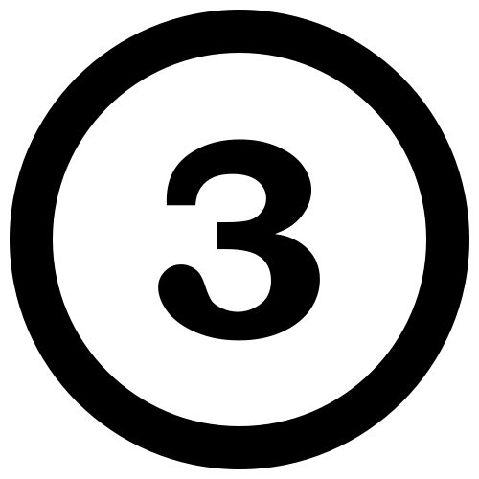 **Round to the place value listed.**

|  |  |  |  |
| --- | --- | --- | --- |
| **Number** | **Nearest Hundredth** | **Nearest Tenth** | **Nearest Whole Number** |
| **90.328** |  |  |  |
| **51.764** |  |  |  |
| **44.299** |  |  |  |

    Graph the following coordinates.

      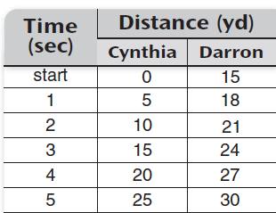

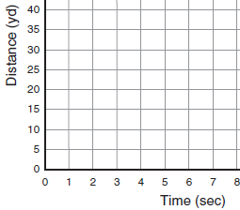

    

+

http://1.bp.blogspot.com/-YCz1FTEvH78/Unm7PzMOAVI/AAAAAAAAPWs/8RyM6X4q514/s1600/7.png a          

Estimate:_______________

Solve:_______________

   b.       

Estimate:_______________

Solve:_______________

  Shade the grid one color to show the starting number. Cross out the number being taken away. Write the difference.

0.56 - 0.12= _____________

[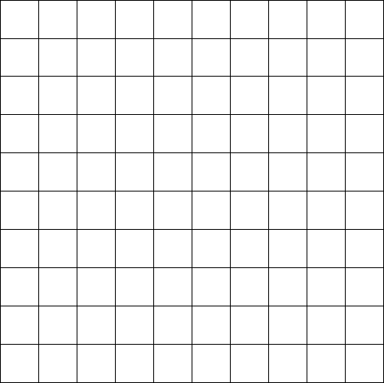](http://www.google.com/url?sa=i&rct=j&q=&esrc=s&source=images&cd=&cad=rja&uact=8&ved=0CAcQjRw&url=http://www.kongregate.com/forums/5-art/topics/132903-100-drinks-collage&ei=5gmDVeysGonEgwS3yoC4BQ&bvm=bv.96042044,d.cGU&psig=AFQjCNECQYa6hDWHZqZJOecCIrcvXZrK6A&ust=1434737503872533)

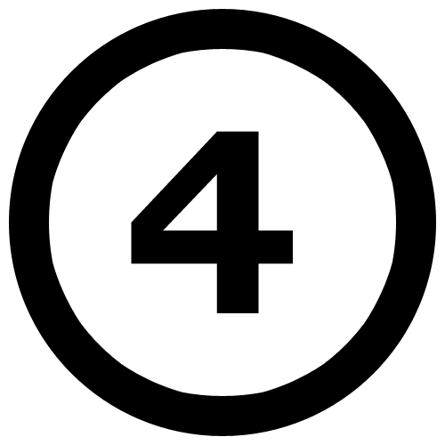 Write the ordered pair for each coordinate points.

