NAME ___________________________________

Grade 5 Unit 2 Review Guide



Due date is Tuesday

Test Wednesday

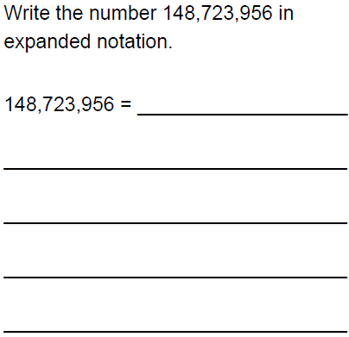

* I am an 8 digit number.
* My four is worth 4 million.
* My 3 is worth 3 (10,000).
* The value of the ones column is double the value of the ten thousand column.
* One of my 2s is worth 200. My other 2 is worth 1/10 as much.
* The other digits are 5.

What number am I? _______________________

 **Write in the missing notation.**

|  |  |  |
| --- | --- | --- |
| **Standard Notation** | **Products of 10s** | **Exponential Notation** |
| **10,000** |  |  |
|  |  | **10 8** |
| **100,000** | **10*10*10*10*10** |  |

                  

http://1.bp.blogspot.com/-YCz1FTEvH78/Unm7PzMOAVI/AAAAAAAAPWs/8RyM6X4q514/s1600/7.png If you read 12 pages a day and you would like to finish a 160 page book, how many days would it take you to finish the book?

Number model: __________________

Answer:________________________

What does the remainder represent?

______________________________________________________________________



**Write in the missing notation.**

|  |  |
| --- | --- |
| **Exponential Notation** | **Standard Notation** |
| **125 * 103** |  |
| **45 * 106** |  |
| **2,125 * 102** |  |



   a         

Estimate:_______________

Solve:_______________

   b.      

Estimate:_______________

Solve:_______________

1. 507 / 9 ?

Estimate:_______________

Solve:_______________

1. 868 / 15 ?

Estimate:_______________

Solve:_______________