Directions for Logging into Teams
- Go to office.com.

- Click sign in.

- Log in with your WSD email address- your computer username @wsdweb.org and click next. For example:

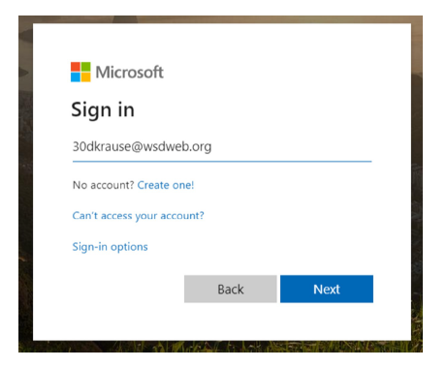

- Enter your WSD password. The same one you use for logging into computers at school.

- Click on the tile that says Teams and wait for it to load.

- Click into your class/teacher team.

- Now you are in our team! On Monday morning, go to the general channel. You will see a meeting you can join on the general channel. Click the “JOIN” button.
- You will have to wait in the “lobby” for your teacher to let you in. When you enter please make sure you are on mute.

