Name______________________________________________________________________________________
BHM project graphic organizer
Person you are researching about: ______________________________________________________________.
Intro paragraph
Hook
Topic sentence
Main idea 1
Main idea 2
Main idea 3
Concluding sentence

First Main idea paragraph (early life)
Topic sentence
Main idea 1
Main idea 2
Main idea 3
Concluding sentence

Second Main idea paragraph (what they are known for – inventions, achievements, interesting facts, personal philosophies)
Topic sentence
Main idea 1
Main idea 2
Main idea 3
Concluding sentence

Third Main idea paragraph (impact on society – how did this person make the world a better place)
Topic sentence
Main idea 1
Main idea 2
Main idea 3
Concluding sentence

Concluding paragraph: Topic sentence restated in new way, 3 main ideas restated, concluding sentence
Topic sentence
3 main ideas restated
Concluding sentence

Model of Introductory paragraph
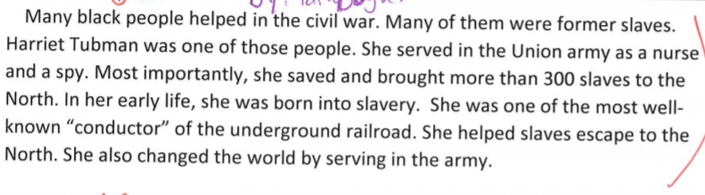
Expert Model: Main Idea Paragraph 1: Early Life
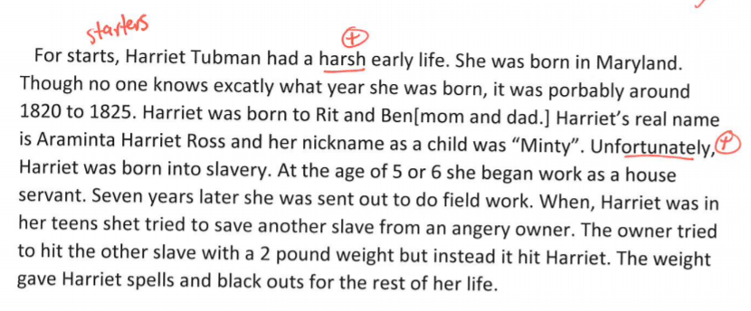
Expert Model: Main Idea Paragraph 2: What were they known for 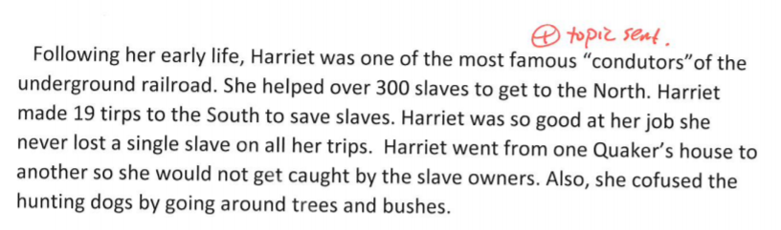
Expert Model: Main Idea Paragraph 3: Positive Impact on the world
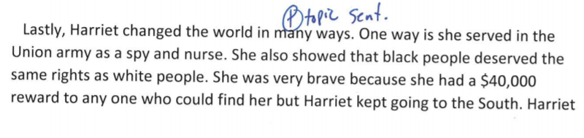

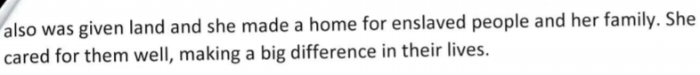
Expert Model: Conclusion
