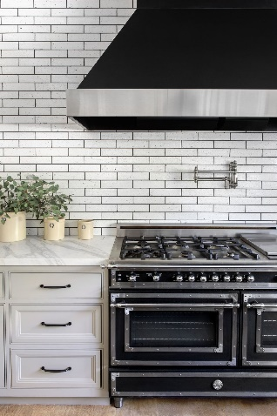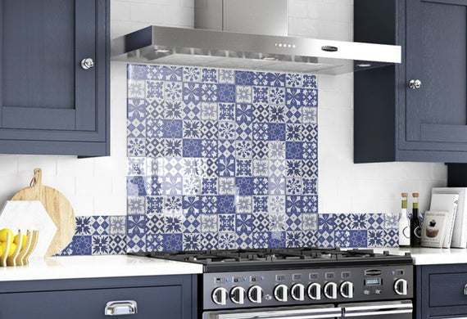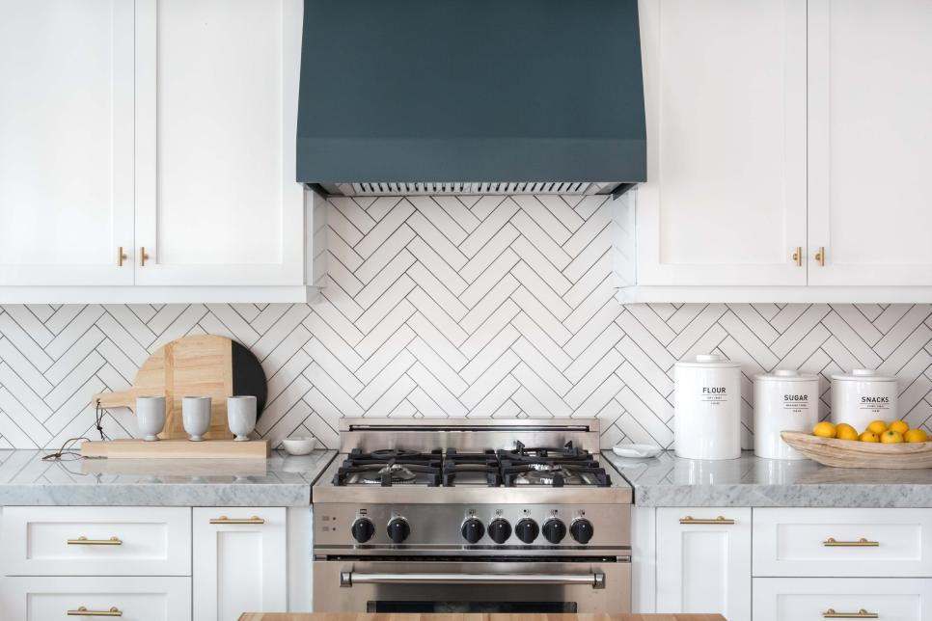
Backsplash Project
Goal: To tile the backsplash area in your kitchen

Criteria: Provide three tile options and choose one

Due date: February 3rd

Results: Share the total cost of the project, clearly explain the calculations and steps of your math, and choose a method to present your project to the class

*If you need any supplies, let your teacher know.
**Rubric attached. Use it to make sure all steps are complete

